Rivonia Fibre

Before we talk about the different providers and what they offer, a few terms:
ISP: Internet Service Provider
Aerial fibre: The provider installs fibre on existing poles (such as Telkom telephone or street light poles) or lays new ones where necessary. I think telephone poles are installed nearly everywhere in our area (if not everywhere, already). Rolling out the service is hence quicker and cheaper to deploy. The downside is that where new telephone poles are installed, some may be concerned that it does not look aesthetically pleasing.
Trenched fibre: Fibre cables are installed underground. As roads and pavements are dug up, the service takes longer to deploy and is more expensive.
Open access: The company installing the fibre infrastructure does not provide any services over it and allows other ISPs such as MWEB, Vox Telecom, etc to do this. Hence, if you already have an adsl service with say Vox, you won’t need to change your service provider at all when moving to fibre. Having multiple providers to choose from allows competition, better pricing and the ability to move to a different one when you are unhappy with the customer service.
VOIP: Voice over IP. This is used to make telephone calls over your fibre line that is no different to a Telkom call.

Service Providers

Fibrehoods
Type of service: Aerial and open access
Likely commencement of rollout: June 2016
Fibrehoods provides the cheapest service. For them to rollout in our area, they need all the respective residents associations to endorse them. They are happy to start marketing their service immediately once this happens. Marketing will include posters in the area, dropping flyers in mailboxes, organising townhalls and emails. Once they attain the required level of signups needed, they will start rolling out their service. Due to high demand, they will likely only be able to start building the network in June 2016.
Website: fibrehoods.co.za
Contact person: Alon Hendel, MD and commercial director.
Email: alon@fibrehoods.co.za

Vumatel
Type of service: Trenched and open access
Likely commencement of rollout: Mid 2016
Vumatel has the most aggressive fibre rollout programme. Their aim is to be in 100,000 homes by the end of next year. Currently, they have 11 neighbourhoods (who have already indicated the required level of interest) waiting for their service. They are hiring more people to help accelerate their rollout rate.
For them to start marketing themselves in the area, they need around 15% of residents to indicate their interest on the website. For them to roll out, 30% take up is required. Unfortunately, they are not willing to compromise on how they have grouped the neighbourhoods:
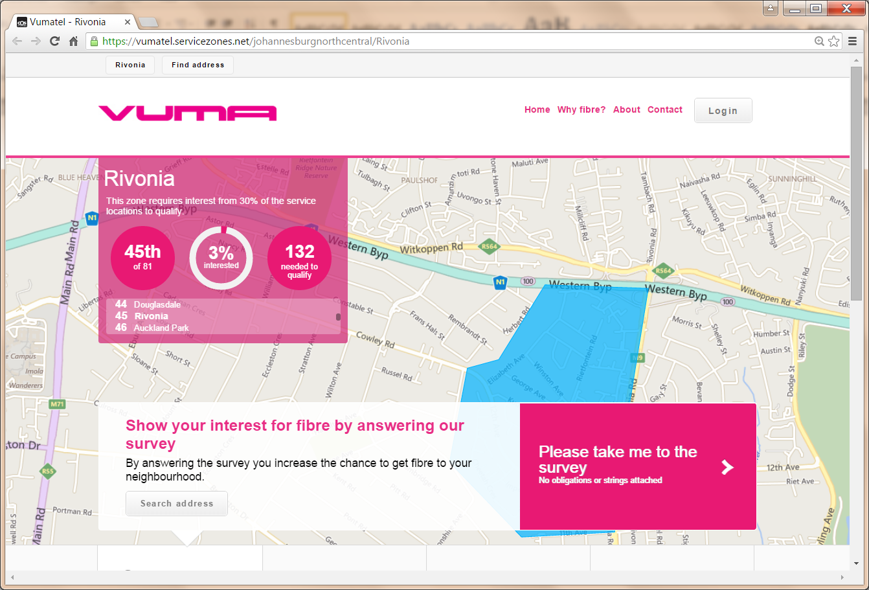
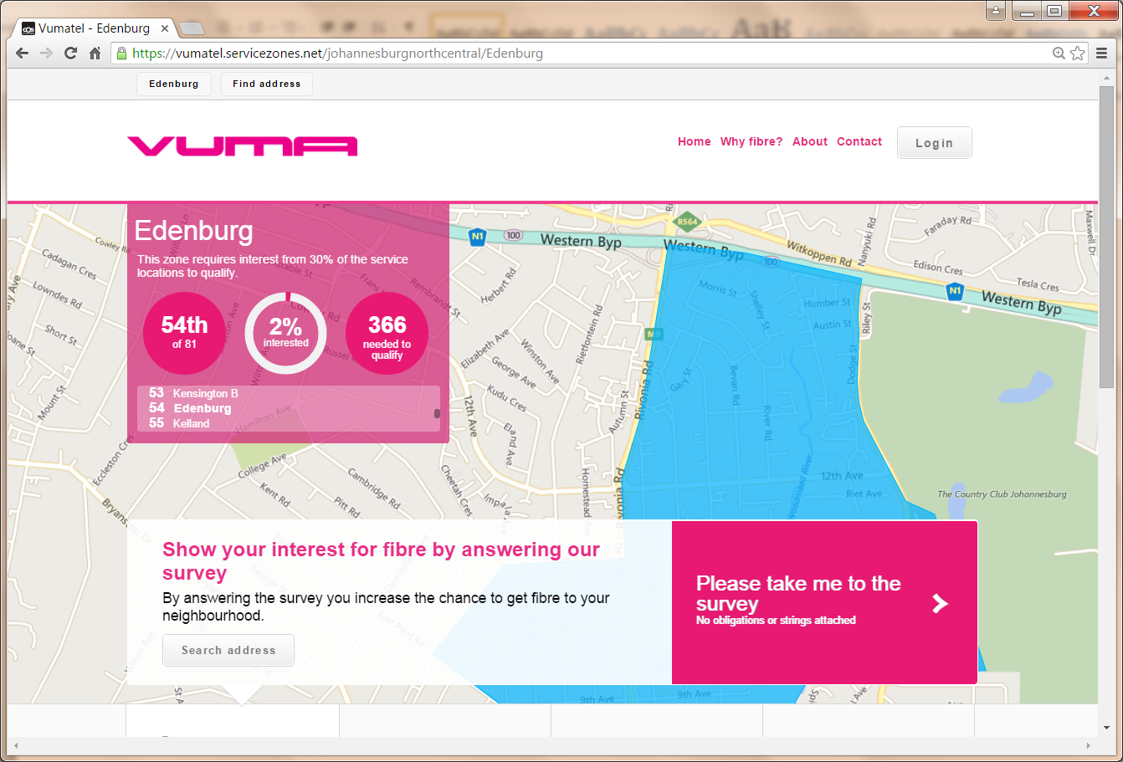
Website: vumatel.co.za
Contact: John Rogers
Email: john.rogers@vumatel.co.za

Metrofibre / Greencom
Type of service: Aerial, not open access.
Likely commencement of rollout: Mid 2016
Already in Sunninghill and have just started rolling out Stiglingh Road, Rivonia/Edenburg. If we endorse them, they are happy to start marketing immediately as well. They do not have the most competitive pricing though.
Website: http://www.metrofibre.co.za
Contact: Amelia von Abo
Email: ameliava@metrofibre.co.za

Cybersmart Lightspeed
Type of service: Trenched, not open access.
Likely commencement of rollout: Not indicated
Although they have fairly competitive pricing, their service is targeted at high density areas such as apartment blocks. I spoke to many people at Cybersmart of the seemingly illogical revenue requirement and the final feedback was, the service only works for complexes/apartments. The revenue requirement is R15/20k pm per 200m stretch of road. For a residential area such as ours, that is 5 to 10 houses.
Website: http://www.lightspeed.co.za

Conclusion
Ultimately, only one provider can come to the area due to the relatively high level of take up required and not everyone will want this service.
In my opinion, we should go with Fibrehoods as they offer:
- Best value for money pricing
- Willingness to start marketing immediately. Hence, nothing further would be required from us after we endorse them.
- Open access service giving residents the greatest choice between who their ISP should be and ultimately the number of different packages available.
Alternatively, Vumatel would be the next best option. Being a little bit more expensive (due to their trenched fibre service), requiring 15% level of interest before they start marketing but still providing residents with a very extensive choice between ISP’s and hence packages available.
Also note:
- Homes/apartments that are tenanted can still take up an account as the account is in the name of the tenant. They simply need permission from their landlord for the fibre cable to be installed.
- All service providers offer a VOIP service allowing you to cancel your Telkom service completely.
- Fibrehoods, Vumatel and Metrofibre all provide a service where they can install street by street cameras. It is up to the community to engage their security provider for the cameras to be monitored.

